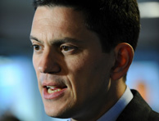  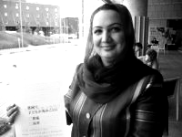  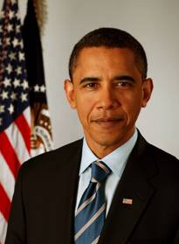  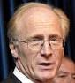  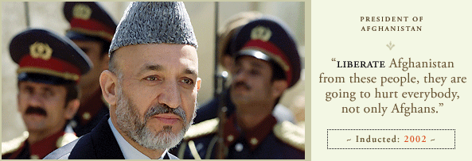 | Which one of these folks is not like the others re: talking to the Afghan Taliban?  It’s not British Foreign Secretary David Milliband.  It’s not former UN Afghanistan chief Kai Eide.  It’s not independent Afghan MP Shukria Barakzai who says that the Taliban “are part of our population” and “every war has to end with talks and negotiations.”  And it’s not Afghan President Hamid Karzai.  All of these folks believe it’s time to begin a national reconciliation process that includes Afghan Taliban leaders willing to join in talks—and signs are, many Taliban leaders are ready to talk.  No, it’s President Barack Obama who is the holdout on talking with the Afghan Taliban. President Karzai is in Washington this week urging President Obama to say “yes” to talks with Afghan Taliban leaders.  We urge President Obama to say “yes” as well.  Hindering Afghan efforts to resolve their differences can only prolong the war and increase its human suffering and material costs.  Organization 1 • Organization 2 • Organization 3  Organization 4 • Organization 5 • Organization 6  Organization 7 • Organization 8 • Organization 9

